Hosting Locally

1. Download and install Microsoft SQL Server Edition.

<https://www.microsoft.com/en-us/sql-server/sql-server-editions-express>

1. Steps to host website locally in IIS (Internet Information Services)
2. In windows**,** go to **turn windows features on or off** from control panel or search from taskbar. Check necessary features. or

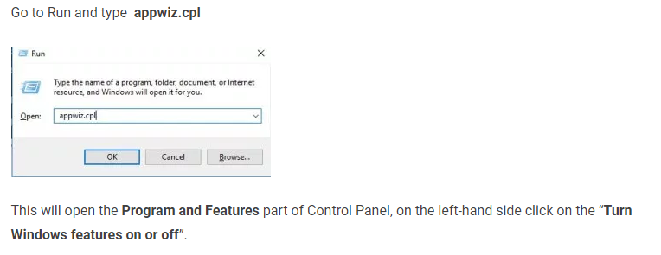

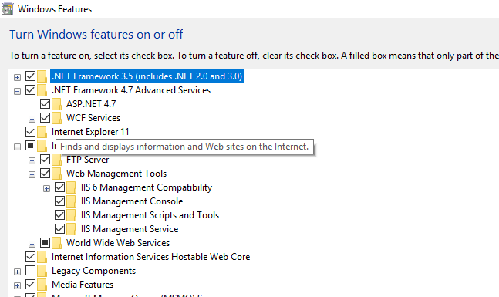

1. Copy source code DigitalMenu or DigitalMenu Inside of Published folder in to C:\inetpub\wwwroot folder.
2. Go to IIS, searching inetmgr or Internet Information Services in taskbar search or Run inetmgr.

From left bar locate DigitalMenu, right click and click on convert to application. Press ok.

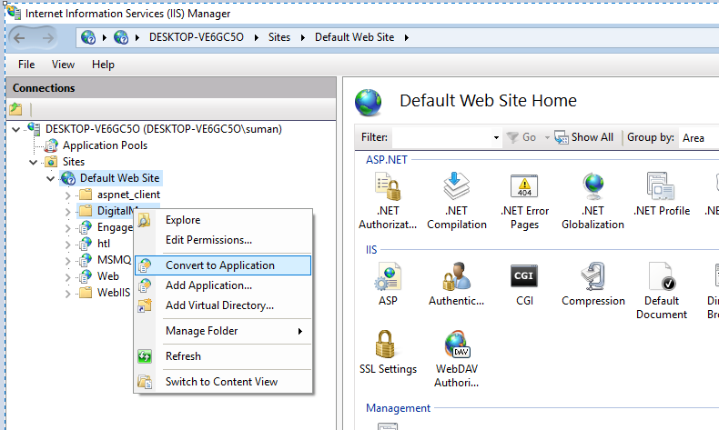

1. Right click DigitalMenu, click Manage Application then Browse. It should redirect to our website in browser.

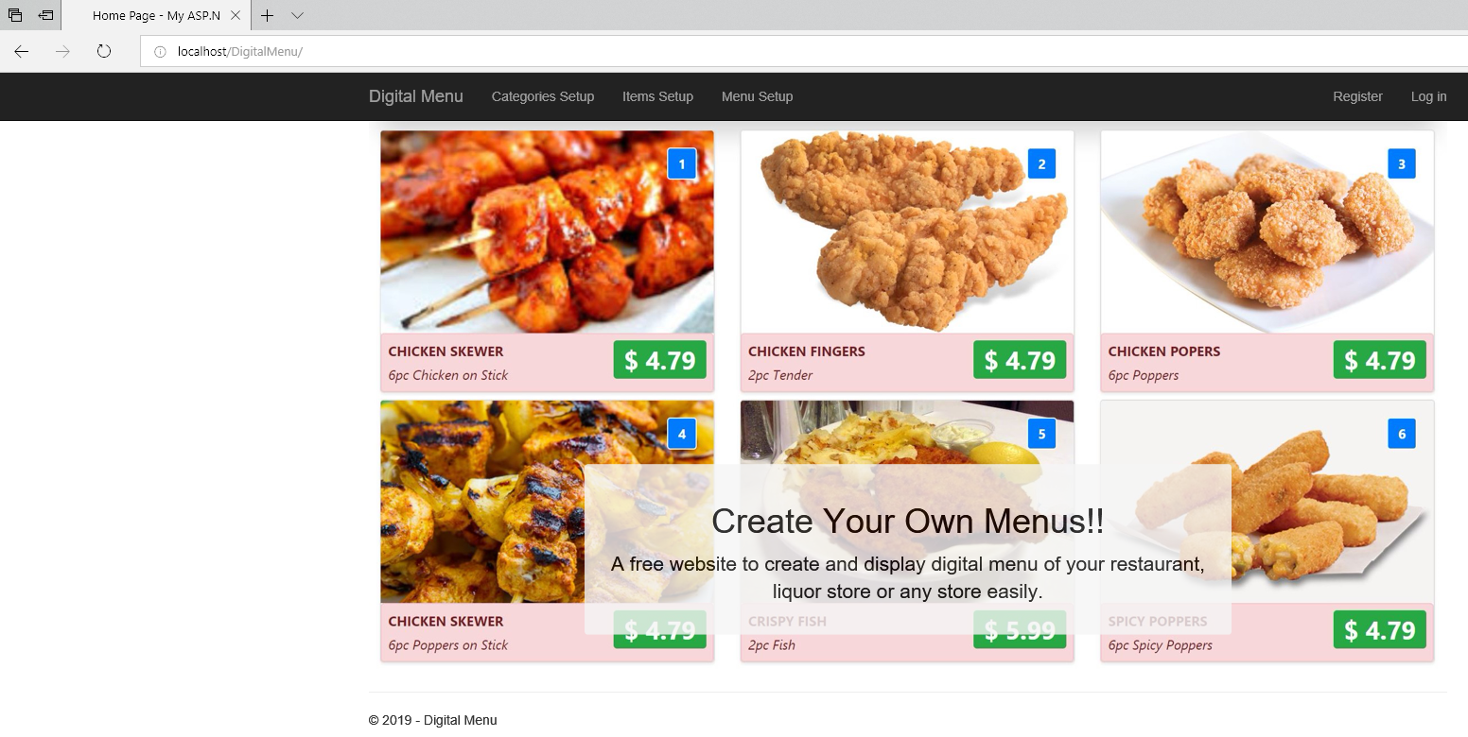

If doesn’t show up site, Possible problems may be

1. Required .net framework not being installed.
2. Default document not set.
3. May need to change connection string in webconfig file of website.
4. Permission errors etc.